**Self 3D mannequin Scope:**

1. Development of a web interface and mobile application compatible with Android and iOS platforms, windows and Mac ensuring maximum user reach.
2. Utilization of advanced computer vision algorithms and machine learning techniques to process the images captured from different angles and generate an accurate 3D self-mannequin with realistic face and texture.
3. Implementation of a robust measurement system that extracts body measurements from the 3D self-mannequin, which will be used to create custom-fit tailored suits/dresses/sarees/blouse.
4. Integration of a 360-degree visualization feature that allows users to virtually try on their tailored suits/dresses/sarees/blouse on the self-mannequin, assessing fitment and style from all angles.
5. Inclusion of a secure user login and profile management system, enabling users to easily access and update their measurements and view their complete history.
6. Development of comprehensive APIs for seamless integration with our website, facilitating a smooth user experience and centralized data management.
7. We believe that our proposed solution will provide your customers with an unmatched personalized experience, transforming the process of purchasing custom-fit tailored suits/dresses/sarees/blouse into a convenient and enjoyable activity.
8. A predefined measurements to be populated after uploading the self mannequin, user should be able to take measurements from point to point with the mouse and store in the measurements table. User should be able to drag and shrink the mannequin at specific area.

Sample Sites for reference: <http://nettelo.com/nettelo-app/>

https://tailor.guide/

Made to measure flow: [https://www.youtube.com/watch?v=dON2oaBiZ-g](https://tailor.guide/e3t/Ctc/I7+113/d2k9Mn04/VWFSn24TzHrZW3lLXPx4x6nXgW2VV8NG4_sqlKN1qZLrh3lLB3V1-WJV7CgW4dW5xD8Fp2vgK6CN4M9s9wSrDGFW49HDK21mT83hW1x-RmW63d7mkW3b87qy22kzgbN42-Sw2sPDFjW29D1Wy3d7SxNN8Xfv5BnFSLBN8P7P2T_krbFW1QRv0N3VjWSnW5vj4fT2mMPQbN7qcDJyDC77mW7rzry839k0-qW16NqGV7jFWY6W3mb2Tk6nhb3bW53KXPp22-cgkW7yhNVB4mYwqCW55FfR83qCpgNVh4yBn2BjqxtW3kqr8S3Qlyp735921)

To test the QR code flow, you can visit our demo store. Please also note the Demo Integration dropdown menu for selecting the correct flow:  
[https://demo.choozr.ai/](https://tailor.guide/e3t/Ctc/I7+113/d2k9Mn04/VWFSn24TzHrZW3lLXPx4x6nXgW2VV8NG4_sqlKN1qZLq_3lLzNV1-WJV7CgWjFW861MGl2X3FRKW3gGfwT5tT9FJW6W4w0d7Bg47qW57Bd_84nYBSmN6RcCv5yW9MXW1-6PBh7nhY5tW584tmN2p0QYvVrw2Rt4kgnJ0W7xBvJS7_4bdNN2pSH6XgszcFW6bJ19z3C9bLhW1FVl8Q3kFzM4W8QlM0n2CC_SCV4MfjB43xHHLW2WhtPf3_GxZHW83Jc4Y1vD2PJW5ds7Dl4hZ7lcW185dQK2TBVDp3dJ11)  
  
Integration documentation can be found here:  
[https://developer.choozr.ai/](https://tailor.guide/e3t/Ctc/I7+113/d2k9Mn04/VWFSn24TzHrZW3lLXPx4x6nXgW2VV8NG4_sqlKN1qZLrh3lLB3V1-WJV7CgDR8W9dCJzR3bC-YmN7dLWtl6L00gW76Z_6_3w04RCW6L5L-03PPKb_N28d3R9jVRbnW4ZVFd53M_yrvW6d33fT8pfm2_W18vKgm1n-8SNW7vqVQh4mpmLqN57T12V1C64pW2xV6844nWJk0W91H3wd68Vhc_W7_KDvR6kdkgGW1hrYlW4kfxVqW2V64jc99xNx8W18GY7l92g7TWW8QPfBP8y8XGPN3qPjYX8NV6RN3jfCjYKflqkW7_0VbZ8cgfdW329M1)  
  
The example link below differs from the demo store in that it has just the minimal stuff needed to get things working, and developers can copy and paste stuff as their starting point:  
[https://github.com/choozr/widget-demo](https://tailor.guide/e3t/Ctc/I7+113/d2k9Mn04/VWFSn24TzHrZW3lLXPx4x6nXgW2VV8NG4_sqlKN1qZLrh3lLB3V1-WJV7CgB8vW8M8BNH7BVJMfW7g_0LV2jLNmLW5kqSv18WnFPpW3WL8ld4kF1njW7K2x3Y8fMPScW8gLMgG952Ws0W2lcynW5d5rZWW861Sw87R4QZ9W99lXnL8ChCjvW5b0XDj2lFTcPW7v4QbJ2PmhR6W7wXhRV6F4Wd-W3Tys-35tQ6hKW61pkzL2s-CJ3N5b-7jS856N8W7t2PcN8-dRJ2W5g54z57FWBYfW6ZglSH6j26gbW6x3YhF63MCG6N2xBZBY8BxC63kM91)

Sample Interface:

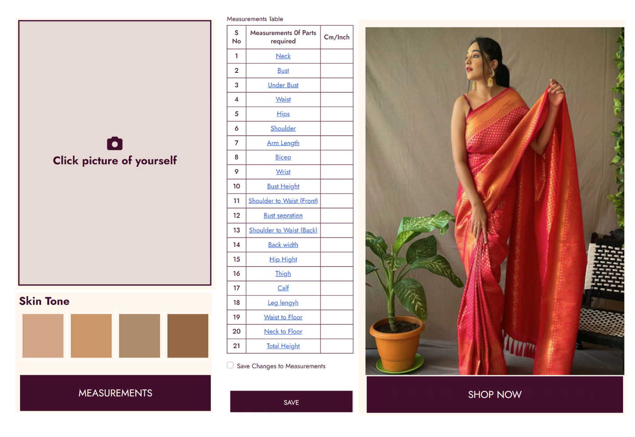

**Technical Options:**

1. **Model:**

Creating a mannequin using a selfie from a camera/mobile is a challenging task that requires advanced computer vision and machine learning techniques. A general approach to creating a mannequin from a selfie would involve:

* Detecting the face and body in the selfie using computer vision techniques such as Haar cascades or deep learning models like OpenPose or YOLO.
* Extracting the pose and shape of the detected body using a human pose estimation model like OpenPose or DensePose.
* Generating a 3D model of the mannequin using the extracted pose and shape information.
* Texturing the 3D model with the skin tone and clothing of the person in the selfie using image processing techniques.

1. **Model:**

Creating a mannequin from a selfie involves using computer/mobile vision techniques to identify and extract features from the selfie, and then using 3D modeling software to create a 3D model of a mannequin based on those features. This is a complex task and would require extensive knowledge in computer vision and 3D modeling.

1. Extract facial features from the selfie using computer vision techniques such as facial recognition and landmark detection.
2. Use the extracted facial features to create a 3D mesh of the face using 3D modeling software.
3. Extrapolate the 3D mesh of the face to create a 3D model of the entire body, using techniques such as body scanning and anthropometric data.
4. Refine the 3D model of the body using the original selfie as a reference.
5. Add details such as clothing and accessories to the 3D model of the mannequin.

Please note that this is a high-level overview of the steps involved in creating a mannequin from a selfie.

1. **Model:**

Creating a mannequin from a web/mobile camera using 3D modeling involves a variety of different steps, including capturing images from the web/mobile camera, processing the images to extract the necessary features, generating a 3D model of the mannequin, and rendering the model in real-time.

Here is a general outline of the steps that you can follow to create a mannequin from a web/mobile camera using 3D modeling:

Capture images from the web camera in real-time using OpenCV.

Detect the body using a human pose estimation model like OpenPose or PoseNet.

Use the body keypoints to generate a 3D model of the mannequin using a library like Blender or PyMesh.

Texture the 3D model with skin tone and clothing using image processing techniques like face and body segmentation, skin tone detection, and clothing detection.

Render the textured 3D model in real-time using a 3D rendering library like OpenGL.

Here is a sample code structure that demonstrates how this can be accomplished: